FitBuddy: AI-Powered Fitness & Nutrition Architect
Google Cloud Generative AI & Full-Stack Web Application

Project Description:
FitBuddy is an AI-assisted fitness and nutrition web application that creates personalized workout routines, nutrition blueprints, metabolic calculations, and conversational fitness guidance. The application combines deterministic calculations with Google Gemini 3.8 Flash for personalized workout, meal, and coaching responses. It is implemented with FastAPI, Jinja2 templates, JavaScript, SQLAlchemy, and SQLite.
The system calculates BMI, BMR, TDEE, calorie targets, macronutrients, and hydration targets, then uses the user's profile, goals, available equipment, experience, session duration, diet type, allergies, and physical limitations to structure the generated plans. Workout plans include warm-up, main exercises, rest times, form cues, cool-down mobility, and progressive-overload guidance. Nutrition plans provide daily meals, calorie/macronutrient breakdowns, and a grocery checklist.
FitBuddy also provides an AI Coach chatbot with conversation history stored in SQLite. The application supports a demo/offline path when an API key is unavailable, and its AI client uses retry and fallback handling for temporary Gemini API failures.

Scenarios
Scenario 1: A user enters age, gender, height, weight, target weight, fitness goal, activity level, experience, equipment, and session duration. FitBuddy calculates BMI, BMR, TDEE, target calories, macros, and hydration, then produces a structured workout plan.
Scenario 2: A vegetarian user selects a weight-management goal and provides dietary restrictions. FitBuddy creates a four-meal nutrition blueprint with calorie and macro targets plus a categorized weekly grocery checklist.
Scenario 3: A user asks the FitBuddy AI Coach for an exercise modification because of a physical limitation. The coach uses the saved profile and recent conversation history to provide contextual guidance, with an offline sports-science fallback when the Gemini service is unavailable.

Technical Architecture:
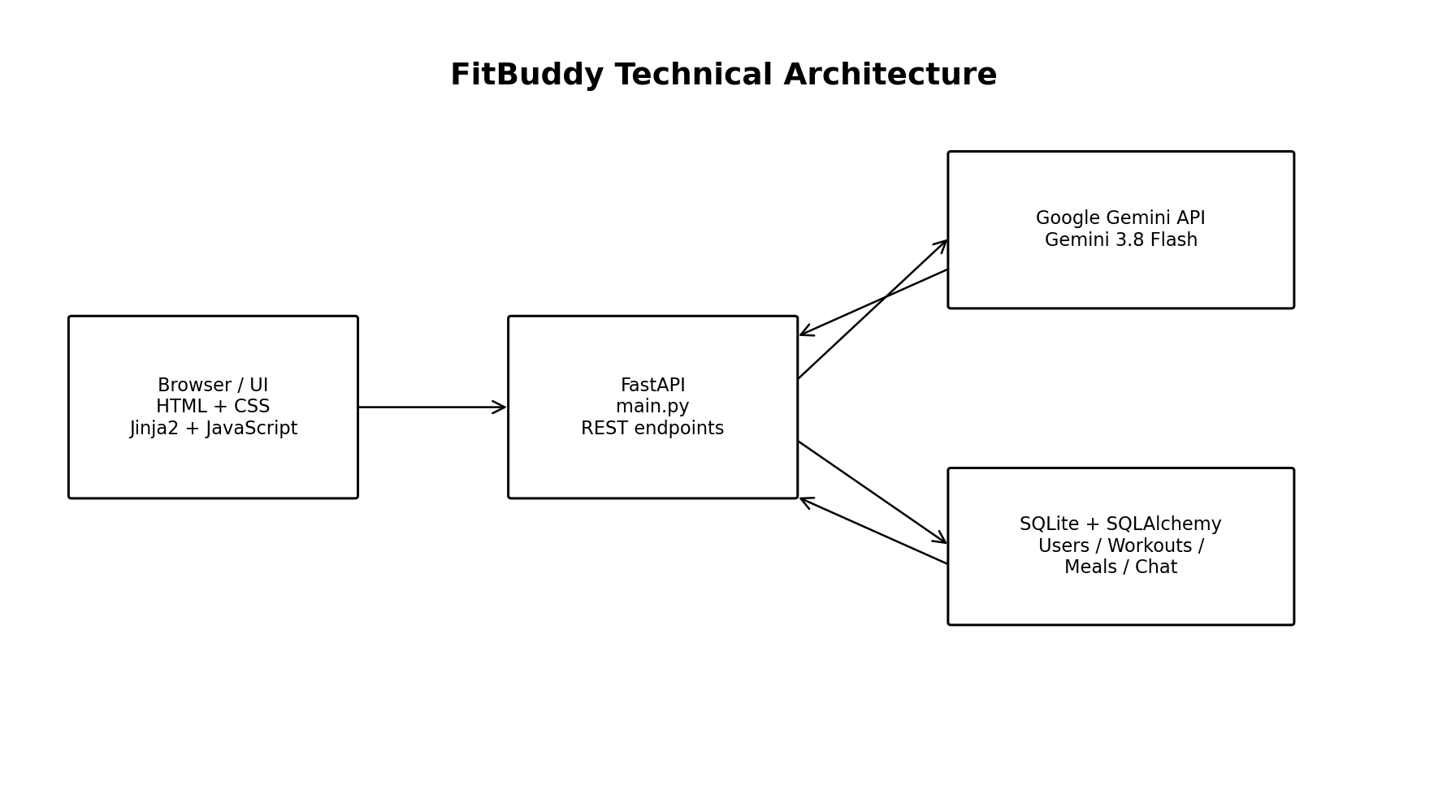
FitBuddy follows a layered full-stack architecture. The browser presents the dashboard through Jinja2 templates and JavaScript. FastAPI handles page rendering and REST endpoints. SQLAlchemy provides ORM access to the SQLite database, while the Gemini client integrates Google Gemini 3.8 Flash for AI-generated workout, nutrition, and coaching content. The application runs with Uvicorn on port 8000.

Database / ER Diagram
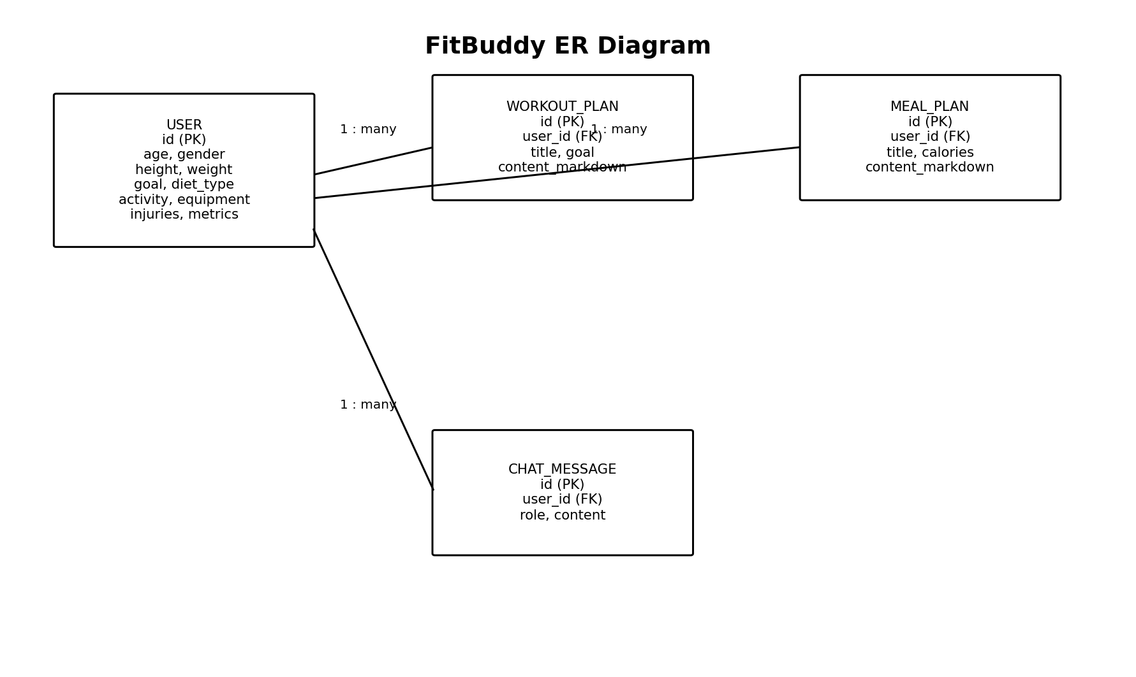
The persistent database contains user profile information and generated content. Workout plans, meal plans, and chat messages reference the user record through user_id foreign keys. This allows generated regimens and coaching conversations to persist between requests.

Pre-requisites:
- Python 3.10 or later and pip.
- FastAPI and Uvicorn knowledge for the web/API layer.
- HTML, CSS, JavaScript and Jinja2 knowledge for the frontend.
- SQLAlchemy and SQLite fundamentals for persistence.
- Google Gemini API familiarity for AI generation.
- Git and GitHub for version control.
- A virtual environment and the dependencies listed in requirements.txt.

Project Workflow:

Milestone 1: Requirements and Architecture
- Identify fitness, nutrition, metabolic-calculation, and conversational-coaching requirements.
- Define the FastAPI, Jinja2/JavaScript, SQLAlchemy/SQLite, and Gemini integration architecture.
- Design the persistent data model for users, workouts, meals, and chat messages.

Milestone 2: Deterministic Metabolic Engine
- Implement BMI and WHO-category calculations and ideal-weight bounds.
- Implement Mifflin-St Jeor BMR and TDEE calculations.
- Calculate calorie targets, calorie mode, macronutrient grams, and hydration targets.

Milestone 3: AI Workout and Nutrition Development
- Build structured workout prompts using user profile and calculated metrics.
- Build nutrition prompts using diet type, allergies, calorie target, hydration, and macro targets.
- Integrate Gemini 3.8 Flash with automatic retry/backoff and offline/demo fallbacks.

Milestone 4: AI Coach and Persistence
- Implement the conversational AI Coach endpoint and session-aware history.
- Persist profile changes, generated workouts, meal plans, and chat messages in SQLite.
- Implement dossier export as a Markdown document.

Milestone 5: Frontend Development
- Create the Jinja2 base layout and interactive dashboard.
- Implement the modern dark glassmorphism styling and responsive layout.
- Use asynchronous JavaScript/AJAX for profile updates, generation, chat, live calculations, and export.

Milestone 6: Testing, Deployment and Documentation
- Install requirements in an isolated environment and run the application with Uvicorn.
- Verify the main dashboard, API endpoints, demo mode, database persistence, and export workflow.
- Use FastAPI Swagger/ReDoc for API inspection and document the completed system.

Milestone 1: Requirements and Architecture
The first milestone establishes the system requirements and defines how the frontend, FastAPI backend, database, deterministic calculation engine, and Gemini AI service work together.

Activity 1.1: Identify Functional Requirements
- Collect user biometrics, fitness goals, activity level, experience, equipment, session duration, and limitations.
- Provide BMI, BMR, TDEE, calorie, macro, and hydration calculations.
- Generate personalized workout routines and nutrition blueprints.
- Provide conversational fitness coaching with contextual profile information.
- Persist generated plans and chat history in SQLite.
- Export the complete regimen as a Markdown dossier.

Activity 1.2: Select the AI Model
FitBuddy integrates Google's official GenAI SDK and uses Gemini 3.8 Flash for workout generation, nutrition generation, and conversational coaching. The client includes retry handling for temporary 503/429 conditions and a fallback path so the application can continue using demo or offline responses.

Activity 1.3: Define the Architecture
- Frontend: Jinja2 templates, HTML/CSS, and asynchronous JavaScript.
- Backend: FastAPI route handlers and form/request validation.
- Business logic: calculator.py for deterministic metabolic calculations.
- AI integration: gemini_client.py for Gemini requests, prompts, retries, and fallback responses.
- Persistence: SQLAlchemy ORM with SQLite in fitbuddy.db.
- Runtime: Uvicorn ASGI server on port 8000.

Activity 1.4: Development Environment
- Create a Python virtual environment.
- Install dependencies with pip install -r requirements.txt.
- Copy .env.example to .env and add GEMINI_API_KEY when AI generation is required.
- Run uvicorn main:app --reload --port 8000.
- Open http://127.0.0.1:8000 in a browser.

Milestone 2: Deterministic Metabolic Engine
The deterministic calculation layer provides repeatable health and nutrition calculations before AI generation. It computes BMI and category, BMR using Mifflin-St Jeor, TDEE, target calories, macros, and daily hydration.

Activity 2.1: BMI, BMR and TDEE
- BMI is calculated from height and weight and mapped to WHO risk categories.
- BMR is calculated using the Mifflin-St Jeor method.
- TDEE is derived from BMR and the selected activity level.
- Ideal-weight bounds are also calculated for the user profile.

Activity 2.2: Calorie and Macro Targets
- Determine calorie deficit, maintenance, or surplus mode according to the selected goal.
- Calculate daily protein, carbohydrate, and fat targets in grams.
- Calculate a daily hydration target.
- Expose the calculated values to the dashboard and AI prompt builders.

Milestone 3: AI Workout and Nutrition Development
This milestone connects the deterministic profile/metrics layer to Gemini. The generated content is structured around the user's actual profile instead of being a generic workout or diet response.

Activity 3.1: AI Workout Generation
- Build a profile dictionary containing age, gender, height, weight, target weight, goal, experience, equipment, days per week, session duration, and injuries.
- Build a metrics dictionary containing BMI, BMR, TDEE, target calories, and calorie mode.
- Send structured prompts to Gemini 3.8 Flash.
- Save the resulting workout plan to SQLite.

Activity 3.2: AI Nutrition Blueprint
- Use goal, diet type, and allergies as nutrition inputs.
- Pass target calories, calorie mode, hydration, and macro targets to the prompt.
- Generate four daily meals/snacks and a weekly grocery checklist.
- Persist the meal blueprint in SQLite.

Activity 3.3: Reliability and Fallback
- Retry temporary Gemini failures using exponential backoff.
- Load a sample workout or meal plan when demo mode is selected or an API key is unavailable.
- Use an offline sports-science coach response when the live coach service cannot be used.

Milestone 4: AI Coach and Persistence

Activity 4.1: Conversational AI Coach
- Accept user questions through /api/chat.
- Save the user's message before generating the response.
- Load recent conversation history and relevant profile/metric context.
- Call Gemini when an API key is available; otherwise use the offline coaching response.
- Save the assistant response to SQLite.

Activity 4.2: Database Persistence
- User profile data is stored in the User model.
- WorkoutPlan stores generated workout content and its goal.
- MealPlan stores generated meal content and calorie target.
- ChatMessage stores user and assistant conversation messages.
- The application creates the database schema through SQLAlchemy models.

Activity 4.3: Dossier Export
The /api/export endpoint compiles the user's profile, latest workout, and latest nutrition plan into a Markdown dossier named FitBuddy_Regimen_Dossier.md.

Milestone 5: Frontend Development

Activity 5.1: User Interface
- Jinja2 base and index templates provide the application shell and interactive dashboard.
- The dashboard presents biometrics, workout plans, nutrition plans, and the AI Coach.
- Custom CSS implements the modern dark glassmorphism visual style.
- The interface is designed to work across desktop and smaller screens.

Activity 5.2: Asynchronous JavaScript
- JavaScript handles AJAX requests without full-page reloads.
- Profile updates trigger live recalculation and dashboard updates.
- Workout and meal generation update the interface dynamically.
- Chat messages are sent asynchronously and appended to the conversation.
- The export action downloads the generated Markdown dossier.

Milestone 6: Testing, Deployment and Documentation

Activity 6.1: Local Deployment
- Create and activate a Python virtual environment.
- Install all packages from requirements.txt.
- Create .env from .env.example when Gemini AI is required.
- Start the server with uvicorn main:app --reload --port 8000.
- Open the application at http://127.0.0.1:8000.

Activity 6.2: API Verification
FastAPI automatically exposes interactive API documentation at /docs and /redoc. The main application also exposes REST endpoints for profile updates, presets, workout generation, meal generation, chat, and export.

Activity 6.3: Safety and Documentation
The application includes a medical and safety disclaimer stating that generated routines and calorie guidelines are educational/informational and that users should consult an appropriate medical professional or certified physical therapist before beginning a new training program.

Key API Endpoints
Endpoint | Method | Purpose
/ | GET | Render the main FitBuddy dashboard.
/api/profile | POST | Update the user's profile and calculated metrics.
/api/preset/{preset_name} | POST | Apply a demonstration/athlete preset.
/api/workout/generate | POST | Generate or load a workout plan and save it.
/api/meal/generate | POST | Generate or load a nutrition blueprint and save it.
/api/chat | POST | Chat with the FitBuddy AI Coach and persist history.
/api/export | GET | Export the complete regimen as Markdown.

Conclusion:
FitBuddy is a full-stack AI-assisted fitness and nutrition application that combines deterministic metabolic calculations, personalized workout generation, nutrition planning, and conversational coaching. Its architecture uses FastAPI, Jinja2, JavaScript, SQLAlchemy, SQLite, and Google Gemini 3.8 Flash, with a persistent data layer for profiles, workout plans, meal plans, and chat history.
The project demonstrates how deterministic calculations can provide a stable foundation while generative AI supplies personalized content. The inclusion of demo/offline fallbacks, retry handling, persistent history, API documentation, and Markdown dossier export makes the application suitable for continued development and testing.
Future enhancements can include stronger authentication and authorization, production-grade cloud deployment, richer progress analytics, wearable/fitness-device integration, notification support, expanded localization, and additional evidence-based personalization controls.

